KINDLY SPONSORED BY ‘THE NORTHERN SNOOKER CENTRE’

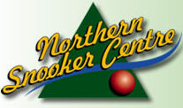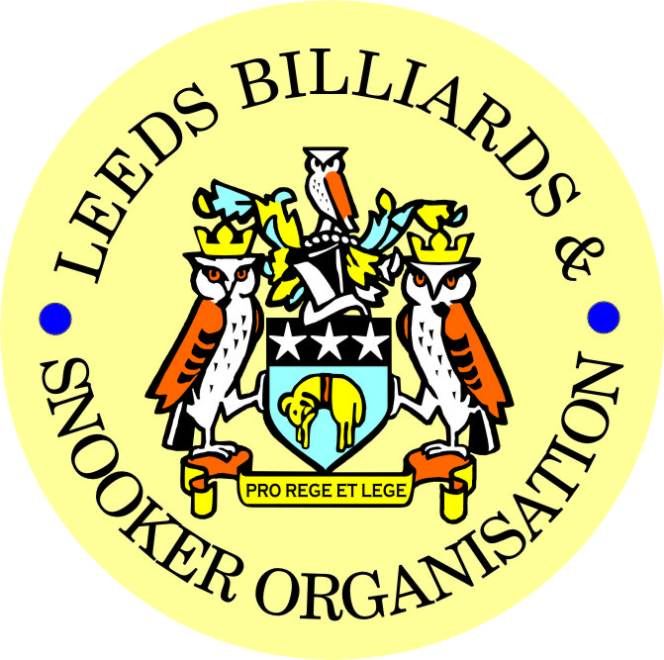

< PETER HAWKYARD >

‘A TRIBUTE TO A LEGEND OF SNOOKER IN LEEDS’

READ OUT AT PETER’S FUNERAL ON FRIDAY 4th APRIL 2014 at PONTEFRACT CREMATORIUM.

DAVINA:
On behalf of everybody associated with the Leeds Billiards & Snooker Organisation (LBSO) and the Leeds and District Referee’s Association, our thoughts are with you and your family at this very difficult time.

****************

LADIES & GENTELMEN:

PETER HAWKYARD:

Davina will be the first to admit I am sure, that Snooker played a very big part of Peter’s life, especially over the past 40 years or so.

Peter had several ‘strings to his bow’-:
- He was a qualified referee with the English Association of Snooker & Billiards (EASB) for a number of years,
- He was an accomplished snooker player,
- He was a long standing member of the Management Committee of the Leeds and District Billiards & Snooker League or the LBSO as it became known in 2006, and
- He was also just a keen lover and enthusiast of the game generally.

*****************

As a referee:
It is uncertain as to actually how long Peter was qualified as a referee with the EASB, but I have recently noted quite by accident, that Peter was recognised for refereeing tournaments in Leeds as far back as 1984 at least, and therefore probably even earlier.

In more recent years, Peter didn’t do much refereeing, but only because he was too busy marking the scoreboard religiously for the LBSO competitions he run so well, travelling in the last few years, from his home to do the 40 mile or so round trip each time.

Apart from myself, the Secretary of the Leeds and District Referees Association Ken Symons, is here today to pay his last respects to Peter and thank him for his services to Snooker as a qualified referee.

*********************

As a player:
Peter was no ‘mug’ when it came to playing the game either, even though many of us might not have actually seen him play.
I don’t think I ever did personally, but if I did it’s a long time ago and I can’t remember.

Someone who can is Brain Chambers currently of Adel Memorial Club and a playing partner of Peter’s from many years ago, who is also here today to pay his last respects.

Brian recently provided me with the following information about Peter as a player, he said-:

Peter Played for Hyde Park Recreation Club from around 1983, Prior to then I think he might have played for Holbeck Pitt.
He was always very competitive playing off a handicap of 5.
His concentration was excellent, every shot was given the utmost care, and he was totally focused on his game. If you happened to be playing on the adjacent table he would hardly notice you, more than once he walked into me while I was playing a shot. His cue action was always very smooth and deliberate.
He joined the league committee when Ernie Lines retired as competition sec. I also think he then took over organising the City of Leeds B team. I know he brought the city of Leeds matches to HPRC . When HPRC closed in 1996 he Joined the Adrian Soc. When he stopped playing he told me it was because he couldn't practice enough, to enable him to play to the standard he wanted. As you rightly say he will be missed by LBSO and all the people who knew him. Sorry I can’t think of much else about Peter, except he was very keen and loved playing and refereeing snooker. Regards Brian

Thanks to Brian, I was able to establish further that Peter actually registered in the Leeds Snooker League for Holbeck Pitt for 3 seasons from 1978/79 to 1980/81, prior to him joining the Hyde Park Recreation Club.

He then first appeared registered for the Hyde Park Recreation Club for the 1983/84 season off a +38 handicap.
He remained registered at this club in the Leeds 6 area, for the next 13 season until the end of the 1995/96 campaign.
During this time, his handicap continued to fall from +38 to +23 (1986/87), to +18 (1987/88), to +14 (1988/89) and finally to +5 (1992/93).
From 1987/88 Peter was ‘top board’ at the Hyde Park Rec. Club for the following 9 seasons while he was there.
In 1996/1997, when the Hyde Park Rec. Club closed, Peter registered with the Adrian Social Club off a handicap of +12 – the same team for which I was also registered at the time in fact.
This season though, more or less signified the end of Peter’s playing career from what I can gather, because of another very significant chapter in Peter’s involvement in Leeds Snooker – that of an administrator generally and specially as a Competition Secretary.

********************

Generally digressing for a moment, again as Brian Chambers says above, Peter was also involved for many years in organising the Leeds Snooker teams in the Yorkshire Inter-District Leagues.

I also know personally, he absolutely adored watching the U.16’s & U18’s in the Leeds Junior Championships, and seeing players like Paul Hunter before and Oliver Lines now, come through the junior ranks in Leeds, made Peter very proud to be associated with Snooker in Leeds.
But in being heavily instrumental in organising these particular competitions, Peter was of course actually a part of their development to professional status, although he probably wouldn’t have allowed people to acknowledge this fact, such was his nature!

**********************

Competition Secretary:
It is though, as Competition Secretary for the Leeds & District League before and now the LBSO, that Peter will undoubtedly be most remembered – and possibly rightly so.

Peter took over the job at the start of the 1996/97 season, after the retirement of another well know name in Leeds Mr Ernest Lines, and since then Peter has become a legend in his own right.

The 2006/07 season saw the amalgamation of the Leeds & District League and the Leeds Billiards & Snooker Association, but when his partner for the year Mick Penny soon retired, since the start of the following 2007/08 season, Peter has single handedly managed the many competitions run in the city of Leeds by the LBSO.

In addition, last year during the whole 2012/13 season, Peter also doubled up as the League Secretary, whilst this position was vacant.
He was also very influential in setting up the league and competition functions, for the superb website we all now have the privilege to share.
So all in all, last season Peter more or less run the LBSO leagues and competitions on his own!

Peter had many good facets.

Firstly he was a gentleman, and this is probably one of the reasons why he stayed at the Hyde Park Rec. Club for so long.
This is one of my first recollections of seeing Peter, and he fit in well at this very classy establishment.

Peter was a very capable fella and dexterous with it. He was articulate but could be quite blunt sometimes when he needed to be, something which I am now finding myself you need to be sometimes.

He was clearly a proud man and very probably more than good at his job, if the professional way he did the Competition Secretary’s job was anything to go by.

He was considerate and it mattered to him that what he did was right and fair to everybody.

He was very thoughtful and a good planner, he had to be but I know now myself, not everybody could do what he did.

It wasn’t always ‘plain sailing’ with Peter though, he could be a stubborn old so and so at times, but he was nearly always proved to be right!
He was never rude or vulgar, aggressive or disrespectful though.

Peter wanted to retire from the position of Competition Secretary altogether at the end of this season. He had been talking about it for a while, but had finally made his mind up.

He would have been sad about leaving the job after so many years I am sure, but simultaneously, I also know he was looking forward to spending more time with his family.

We were all looking forward to sending him off in style as well, to thank him properly for all the hard work he had done over the last 18 years or so particularly.

Unfortunately, we have all been deprived of that opportunity we were some much looking forward to, and we are here today under these very different and sad circumstances.
Apart from myself, there are a number of officials and players from the LBSO here today, to pay their last respects to Peter.

********************

We are all united in saying:

Peter, thank you for everything you did for Snooker in Leeds.

You have left a lasting legacy which many will be proud to follow and for many years to come.

********************

Peter - Rest in Peace.

From the Management Committee, officials, players and everybody else associated with the LBSO and the Leeds Referees Association.

Bob Patterson
LBSO General Secretary.

